Whareroa Farm Recreation Reserve Tender Opportunity

Process under s17ZG(2)(a) of the Conservation Act 1987 to manage the Whareroa Farm Grazing Opportunity within the Whareroa Recreation Reserve.

- Introduction

The Whareroa Farm Recreation Reserve (“Whareroa Farm”) is located on the Kapiti Coast.

The Department of Conservation (“the Department”) wants to consider options for a new grazing Licence for grazing a large part of the farm. To do this, the Department has decided to run an Open Tender process (OT) which provides a transparent process to determine the most suitable tender for the opportunity at Whareroa Farm. This is a process implemented under s17ZG(2)(a) of the Conservation Act 1987. S17ZG(2)(a) has been approved for a period of five months and will expire on 21 April 2023. While this process is in place, the Department will not be accepting concession applications.

The tenders will be assessed on their overall merits, based on the criteria more fully described at section 5.0 of this document.

Following the OT process, one or more Tenderer(s) may be invited to apply to the Department.

Proposal Timeframe:
The Department will be accepting Tenders from 9:00am Friday 18 November 2022 to 5.00pm Friday 16 December 2022.

Please review the following documentation and ensure you understand the full process. Contact the Department if you have any queries about your Proposal or the wider process. Email permissionshamilton@doc.govt.nz – Darcy Liddell, Permissions Advisor.

- Context

The Whareroa Farm is located on the Kapiti Coast near Paekakariki and was previously grazed under concession 43056-GRA. The land was grazed in conjunction with Queen Elizabeth Park (QEP) which is managed by the Greater Wellington Regional Council (GWRC). Recently, the GWRC decided to revoke the grazing status of QEP and will not be offering a concession for QEP.

The Department wants to continue grazing Whareroa Farm due to fire risk/fire management for the next 3 years initially.
Whareroa Farm is currently being grazed in the interim (with approval from the DOC Wellington Office) but a formal concession process now needs to be initiated.

- What Tenders are being sought for:

This OT process is an invitation for suitably qualified persons to submit a Tender for grazing of Whareroa Farm.

  - Administration

The Reserve is named Whareroa Recreation Reserve administered by the Department as a Recreation Reserve. The purpose is for providing areas for the recreation and sporting activities and the physical welfare and enjoyment of the public, and for the protection of the natural environment and beauty of the countryside, with emphasis on the retention of open spaces and on outdoor recreational activities, including recreational tracks in the countryside (s17).

The Reserve is administered in accordance with the Reserves Act 1977 and the Conservation Act 1987, and the Wellington Conservation Management Strategy 2019 - 2029.

  - Location, access, and description of land/facilities

Whareroa Farm is located near Paekakariki. Please visit our website for further information – Whareroa Farm: Kapiti places to visit (doc.govt.nz).

Description of Land:
The location and extent of the Farm is shown below:

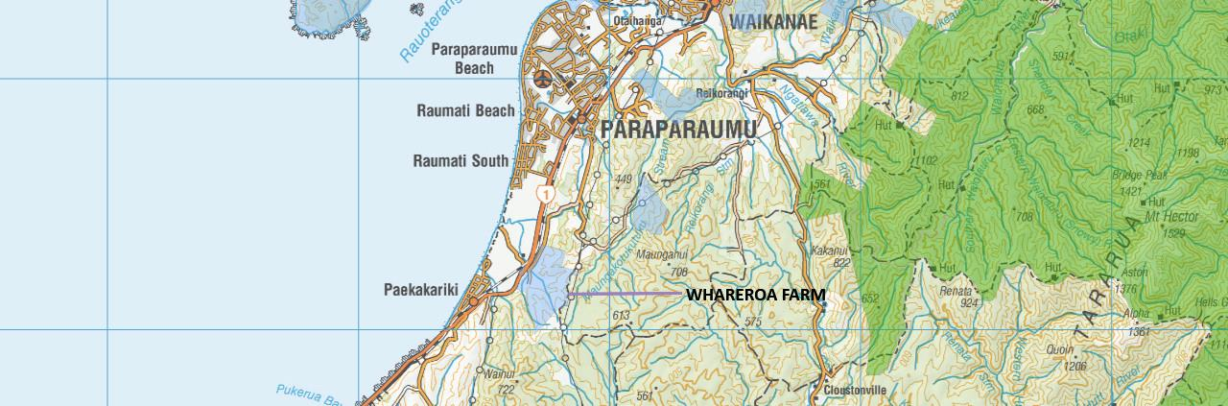

The legal description is Part Sec 1 SO 36580
The grazing opportunity is over an area of 171.53 hectares from February 2023 onwards which is just over a third of the greater Whareroa Farm. A map showing the grazing area in yellow outline is below:
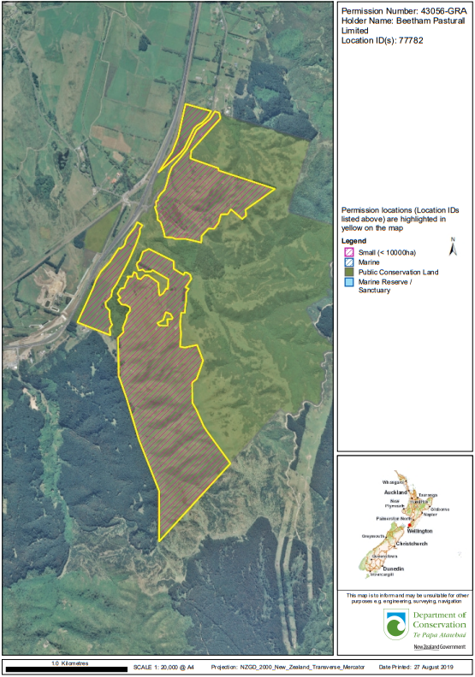

Only sheep may be grazed. Currently 675 sheep are grazed but the finalised sheep stocking number will be determined once a concession application is received.

Conditions of Grazing:
Any grazing concession issued will be for a maximum term of 3 years.

The most recent annual activity fee was a base fee of $29,000 + GST as of October 2019 based on 171.53 hectares for sheep and cattle. The annual activity fee set for the concession will be determined by a valuer once a concession application is received and will take into account what infrastructure upgrade works are proposed by the Tenderer. Fencing upgrade costs will be approximately $52,000 to $70,000 but may be less than this depending on agreement between the Department and Concessionaire over extent of fencing needing to be upgraded.

Assets on the land:
Stock Yards
Water Supply Dams, Intakes, Pipes and Troughs
Farm races and tracks
All farm fences and gates

Note: All assets are owned by the Department. The Concessionaire shall be responsible for their maintenance during the term of the concession.
Note: Assets require an upgrade in places. Much fencing is of poor quality and needs extensive maintenance work in places. The farm races are badly eroded with potholes. Many gates are damaged and the water supply is erratic depending on streams.
Note: Photos of the existing assets are at Appendix Two.

- Tender process

  - Concession management

The Minister has implemented an OT process for a license opportunity at Whareroa Farm under s17ZG(2)(a) of the Conservation Act 1987.

  - Stages of process

  - Step One:
The OT process will be open 9:00am Monday 2022 to 5:00pm 2022 (a 4-week window). Please ensure your tender is provided to permissionshamilton@doc.govt.nz by this closing date and time.

Ensure you have read all OT process Documents and understand what is required. Please get in contact with the Department if you have any queries about this process.

Note: The Department may answer questions of clarification about the context and about the OT process, but cannot help to write, review or complete your tender for the purposes of impartiality.

  - Step Two:
The Department will follow the process for consideration of Tenders set out in section 8.0 below.

  - Step Three:
The Minister will determine the most appropriate course of action in light of having evaluated the Tenders. A possible outcome includes (without limitation):

- One or more Tenderers may be invited to apply for a Licence concession under Part IIIB of the Conservation Act 1987.

What is required from you?

Please submit the following:
- Fill out and submit the application form attached below in Appendix Two with the lodgement fee; and

- Provide a complete Tender by including all information required under section 5.0 - Tender criteria.

There is no tender template. Please provide all relevant information in a clear and logical format.

- Tender Criteria

The Tender criteria contains various components. Tenderers must provide all of the information requested in sections 5.1-5.2. For each section points will be awarded and added up to a total value.

A failure to provide the requested information may result in a Tender being removed from consideration.

Activity Details
- Paragraph 5.1 of this document refers to details of the tender and whether it is suited to the status and significance of the land.

Tenderer capacity
- Paragraph 5.2 of this document refers to the ability of the Tenderer to carry out the tender activity based on experience and connection to the land.

You should refer in your responses to applicable legislation and the planning documents.

  - Activity details

There is one decision to be made in respect of these criteria:
- How suited is the Tender to the status and significance of the land?

    - Whareroa Farm values and features

Discuss how farming can be managed to maintain and enhance the following:

      - Whareroa Farm
Discuss how grazing on Whareroa Farm can give effect to and recognise the following:
        - Interests of Ngāti Toa; and
        - Te Ati Awa
        - Interests of wider iwi and hapū.

      - Farm Significance to the wider public
        - The significance of the Farm to other residents of the Kapiti Coast and Aotearoa.

      - Heritage and archaeological sites
        - Protect and preserve all heritage and archaeological sites across the Farm.

      - Recreational users
        - Maintain maximum access for the wider public in line with the natural environment and recreation values of the Reserve, taking into account the reasonable requirements of the farming operations.
        - Ensuring public safety while on the Reserve.

      - Other organisations
        - Work with existing organisations involved in conservation and recreational activities on Whareroa Farm such as the Whareroa Guardians Community Trust.

    - Land management

Discuss how farming can be managed to maintain and enhance the following:

Land
      - Sustainable farming practices
        - Managing land in a way that is environmentally and ecologically sustainable. This includes low carbon techniques that are friendly to the forest, pasture, freshwater and marine ecosystems.
        - Sustainably managing soil/land to protect sensitive areas, the adjacent marine environments and recreational use (e.g. soil damage, erosion, dangerous areas).

      - Managing the land in a manner appropriate to its land use capability classification.

      - Ensuring riparian and adjacent waterway and waterbody areas are managed appropriately.
        - Fencing off areas for restoration/replanting where appropriate and working with other organisations involved in the Reserve.
        - Promote retiring and restoration of further areas of high risk.

      - Managing trees and vegetation on Whareroa Farm (such as dangerous and fallen trees).

      - Managing soil fertility. The Concessionaire will be required to fertilise the soil in accordance with an agreed fertiliser plan. This will be agreed to by the Minister annually.

      - Managing weeds including Gorse and Blackberry.

Stock Management
      - Stock Welfare
        - Providing stock feed, particularly in winter months or drought periods.

      - Stock use
        - Managing stock types/rates (sheep, stock weight and zoned activity use limits).

Waste Management
      - Ensuring waste is disposed of quickly and sustainably.

      - Ensuring dead animals are disposed of safely, in accordance with appropriate standards and without disturbing archaeological sites.

    - Whareroa Farm infrastructure

      - Contributing to roading maintenance and development if required.

      - Upgrade/replace and maintain all fencing, gates, farm races and tracks in good condition
        - To contain stock in the grazing area and protect high priority areas where required (e.g. for native planting; restoration of waterways).
        - Provide a plan for upgrading/replacing fencing, gates, farm races and tracks
      - Maintaining water supply infrastructure.

      - Maintaining all structures on the land
        - This includes all structures authorised under a grazing licence.

  - Tenderer capacity

There is one decision to be made in respect of these criteria:
- Is the Tenderer suitable by virtue of experience, and connection to Whareroa Farm to carry out the Proposal (either alone or in conjunction with others)?

    - Farming experience

Please outline your wider farming experience. Refer to past examples of farming experience which support your ability to carry out the Tender activity. If you plan to carry out the Tender activity in conjunction with other parties, please outline how you expect the parties to work together to achieve the desired outcomes.

Please provide references as appropriate.

    - Connection to Whareroa Farm

Please describe your connection to Whareroa Farm, including any historical connection. Discuss how this connection supports your Tender.

- Process for Consideration of Tenders

  - Evaluation process

All Tenders received will be evaluated following the process set out below.

    - Stage One

Tenders will be checked to ensure that Tenderers have submitted a complete Application including the application form at Appendix Two, receipt of lodgment fee and all of the information requested in paragraphs 5.1-5.2 of this document. This evaluation is to determine the presence of the information, not the quality.
If Tenderers can demonstrate that they have made a reasonable attempt to provide this information, their Tender will be considered in Stage Two. Otherwise the Tender will be returned within 5 working days of the Stage one assessment being completed.

    - Stage Two

The Department will assemble a panel to assist the Minister review Tenders that have passed Stage One.

Tenders will be assessed on their overall merits, based on the Tender criteria and the extent to which they give effect to:
      - the relevant statutory planning requirements for Whareroa Farm; and
      - Whareroa farm’s significance to Ngāti Toa, Te Ati Awa and other hapu and iwi

No particular weightings will be assigned to the Tender criteria, as the Minister will assess the Tender as a whole. However, the Minister will be guided by the requirements of the Conservation Act 1987, including the requirement in section 4 to give effect to the principles of the Treaty of Waitangi, in administering and interpreting the Act.

While wider recreational and conservation opportunities are not included in this OT process, the Minister may consider any information provided by Tenderers as to any current or potential future involvement in such opportunities and how their Tender may relate to these.

  - Due diligence

In addition to the above, the Department may undertake the following due diligence in relation to shortlisted Tenderers. The findings will be taken into account in the evaluation process:

    - Reference check the Tenderer.
    - Other checks e.g. Companies Office.

- Terms and conditions of OT process

  - Open Tender Period/submission of Proposals

Written Proposals will be accepted at the Department of Conservation Hamilton Office, Level 4, 73 Rostrevor Street, Private Bag 3072, Hamilton 3240 or can be emailed to dliddell@doc.govt.nz until 5:00pm on Friday 16 December 2022.

Tenders received after this date will not be considered unless it can be shown that the tender was delivered late due to unanticipated factors out of their control. Tenders need to take into account the standard mail delivery timeframe.

Tenders must be addressed to Darcy Liddell, Permissions Advisor, and marked on the top outside left-hand corner “Request for Tenders – Whareroa Farm.”

  - Complete Proposals/Applications

Only Tenders which are complete that include the applicant details in the application form and refer to all of the criteria in paragraphs 5.1 to 5.2 (including all information requested within the subparagraphs) will be considered.

Tenders from a partnership or unincorporated joint venture must include the full names and addresses of all partners or members of the joint venture. If a Tender is signed by one person, that person may be asked to provide evidence of authority to act on behalf of the other partners or members.

The cost of preparing and submitting a Tender shall be borne by the Tenderer.

Applications must be accompanied by the OT Lodgement Fee. Any Tender received without the OT Lodgement Fee will not be accepted.

  - No concession application

The Tender Documents and any other information provided under this process shall not be treated as a concession application pursuant to Conservation Act 1987. Tenders will be assessed for the purposes of selecting the most suitable Tender(s). A Tenderer may be invited to apply for a concession once all Tenders have been considered.

  - Ownership/confidentiality

The OT Documents and any other documents resulting from this OT process are the property of the Minister.

Subject to other legislative requirements, Tenderers may ask for their Tender Documents to be returned in a reasonable condition within two months after the closing date of the OT Period.

The Minister will take reasonable steps to protect the OT Documents and, subject to the provisions below, will not disclose the Tenderer’s Confidential Information to a third party without the Tenderer’s prior written consent.

The Minister may disclose the Tenderer’s Confidential Information to any person who is directly involved in the OT process on its behalf, such as officers, employees, consultants, contractors, or professional advisors, evaluation panel members, but only for the purpose of participating in the Tender Process.

The Minister’s obligations are subject to requirements imposed by the Official Information Act 1982, the Privacy Act 1993, parliamentary and constitutional convention and any other obligations imposed by law.

  - Third party information

Each Tenderer authorises the Minister to collect additional information, except commercially sensitive pricing information, from any relevant third party (such as a referee or a previous or existing client) and to use that information as part of its evaluation of the Tenderer’s Tender.

Each Tenderer is to ensure that all referees listed in support of its Tender agree to provide a reference.

To facilitate discussions between the Minister and third parties each Tenderer waives any confidentiality obligations that would otherwise apply to information held by a third party, with the exception of commercially sensitive pricing information.

  - Amendments to Open Tender Documents

Where any amendment to the OT Documents is considered necessary by the Minister, a notice of amendment (Notice of Amendment) shall be published on the Department’s website and sent to all Tenderers and persons who have previously expressed an interest in the OT process. Any such amendment shall, upon notification, become part of the OT Documents.

Where the Minister issues a Notice of Amendment, Tenderers have the right to withdraw their tender, modify it in light of the Notice of Amendment and resubmit their tender within the time specified in the Notice of Amendment.

  - Statutory or other requirements

It will be the sole responsibility of the Tenderer to ensure they can meet any statutory or other requirements to carry out their tender.

  - Lodgement Fee

Tenderers must pay a non-refundable lodgement fee of $500.00 + GST with their proposal to offset the costs of running the Open Tender process.

The OT Lodgement Fee may be submitted by way of internet bank transfer as per the following details:
Department of Conservation
Westpac 03 0049 0002808 00
Reference: Whareroa Farm Grazing Licence Opportunity
Proof of transfer must be included with the application form.

  - Tenderers to be satisfied

Tenderers are considered to be fully aware of the conditions relating to this OT process and to have examined the OT Documents and any other information supplied in writing.

Tenderers are deemed to have satisfied themselves before applying as to the accuracy and sufficiency of their Tender Documents.

  - No obligation

The Minister has no obligation whatsoever to compensate or indemnify any Tenderer for any expenses or loss that the Tenderer may incur in the preparation of their OT. There is no guarantee that any Tender will be accepted, and/or subsequent process run, and/or any concession granted.

The Minister will give written notice to all Tenderers who have submitted bona fide proposals advising the outcome of the OT process.

The Minister is not bound to:
- Accept any Tender;
- Give any reason to any person for the rejection or otherwise of any Tender;
- Complete the OT process.

The Minister reserves the right:
- To reject any Tender;
- At any time to withdraw the Reserve or any part of the Reserve from the OT notwithstanding that proposals may have been called for and / or received;
- At any time to withdraw the OT or again call for proposals or consider further proposals received in accordance with Part IIIB of the Conservation Act 1987.

  - No contract

Neither the OT, nor the OT process, creates a process contract or any legal relationship between the Minister and any Tenderer.

The fact that this OT process is being conducted is in no way to be taken as an indication that a concession will be granted. That decision is one for the Minister to make under Part IIIB of the Conservation Act 1987 and is entirely separate from this OT process.

  - Disclaimer

The Minister will not be liable in contract, tort, equity, or in any other way whatsoever for any direct or indirect damage, loss or cost incurred by any Tenderer or any other person in respect of the OT process.

Nothing contained or implied in the OT, or OT process, or any other communication by the Minister to any Tenderer shall be construed as legal, financial or other advice. The Minister has endeavoured to ensure the integrity of such information. However, it has not been independently verified and may not be up to date.

To the extent that liability cannot be excluded, the maximum aggregate liability of the Minister, its agents and advisors is $1.

  - Tenderers’ Enquiries

Should interested parties have any questions in relation to the OT process, please make contact in writing with the Department:
Darcy Liddell, Permissions Advisor
Department of Conservation
Private Bag 3072
Hamilton 3240
Subject Line: Whareroa Farm – Request for Tenders or;
Email: dliddell@doc.govt.nz

  - Definitions

“Application” means an application in the form set out in appendix three.

“Confidential Information” is information that:
- is by its nature confidential (including culturally sensitive information)
- is marked by either the Minister or a Tenderer as ‘confidential’, ‘commercially sensitive’, ‘sensitive’, ‘in confidence’, ‘top secret’, ‘secret’, classified’ and/or ‘restricted’
- is provided by the Minister, a Tenderer, or a third party in confidence
- the Minister or a Tenderer knows, or ought to know, is confidential.

Confidential information does not cover information that is in the public domain through no fault of either the Minister or a Tenderer.

“Tenderer” means a person who submits a Tender. The term Tenderer includes the individual submitting the proposal and any entity or group on whose behalf it is submitted, together with its officers, employees, contractors, consultants, agents and other nominated contact persons.

“OT Period” means the period from 9:00am Monday 2022 to 5:00pm 2022.

“Tender Documents” means all documents submitted in support of a Tender.
Appendix One
INFORMATION SHEET

- CLOSING DATE FOR ACCEPTANCE OF TENDERS
5:00PM, 2022
Delivered to the Department of Conservation, Hamilton Office,
Level 4, 73 Rostrevor Street,
Private bag 3072,
Hamilton 3240
Attention: Darcy Liddell, Permissions Advisor – Whareroa Farm – Request for Tender

Or Email: dliddell@doc.govt.nz
Subject Line: Whareroa Farm – Request for Tender

- DEPARTMENT OF CONSERVATION CONTACT
Darcy Liddell, Permissions Advisor
Department of Conservation
Private Bag 3072
Hamilton 3240
Phone: 027 536 6915
Email: dliddell@doc.govt.nz

- APPLICATION CHARGES
Lodgement Fees:
Tenderers must pay a non-refundable lodgement fee of $500.00 + GST with their application to offset the costs of conducting this OT Process.

Appendix Two
PHOTOS OF EXISTING ASSETS

Water Supply:

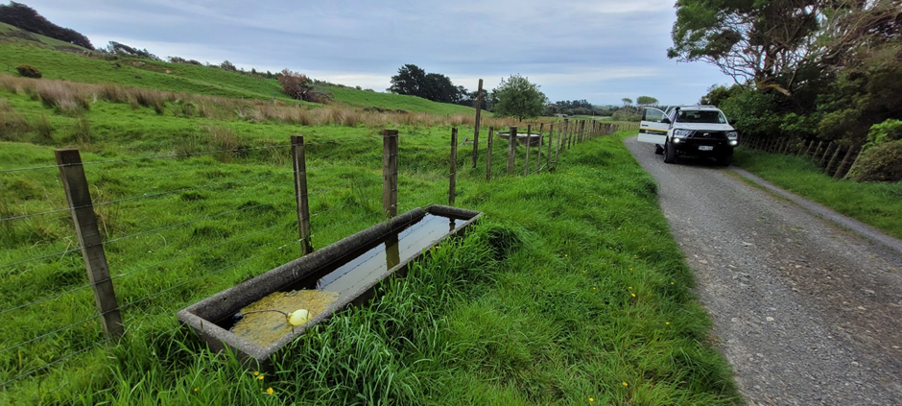

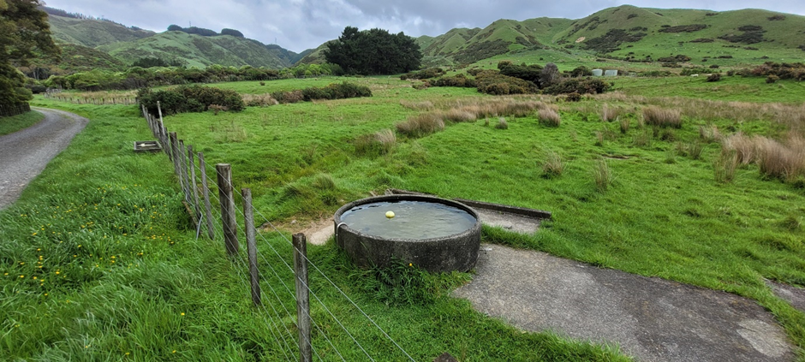

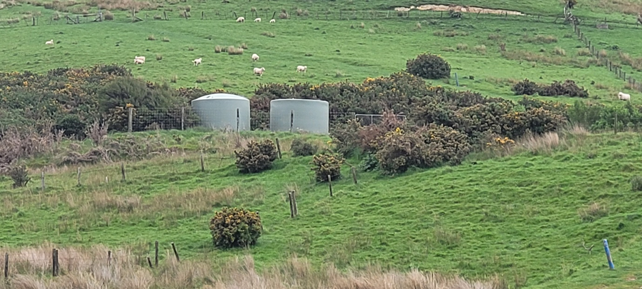

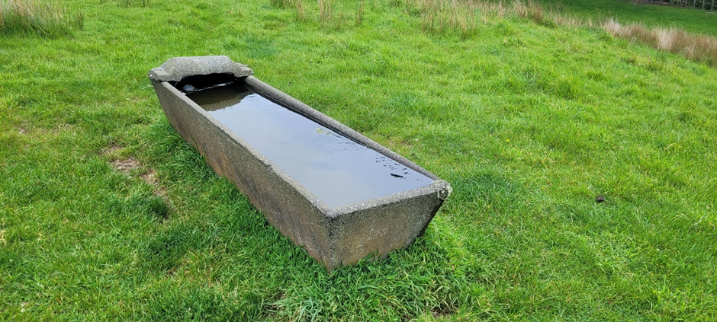

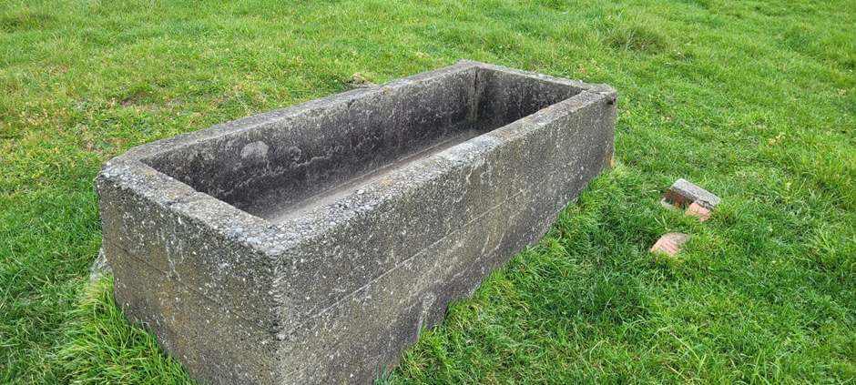

Fencing:
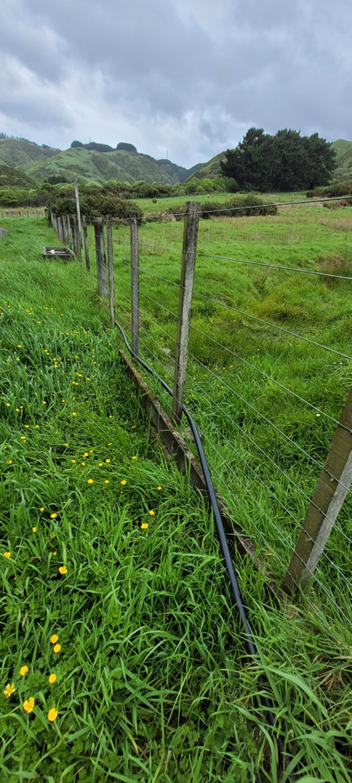
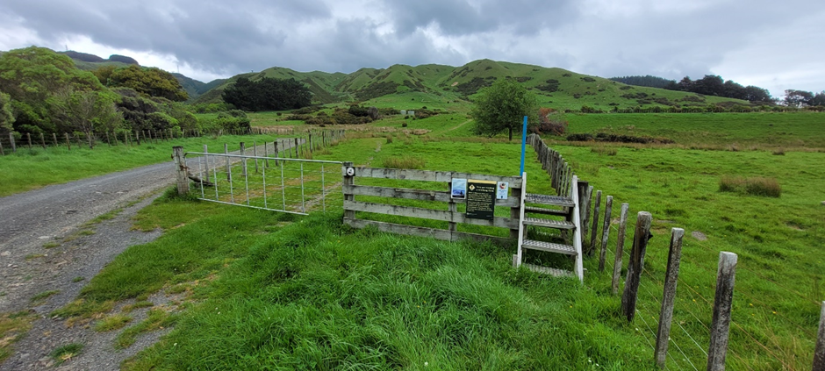

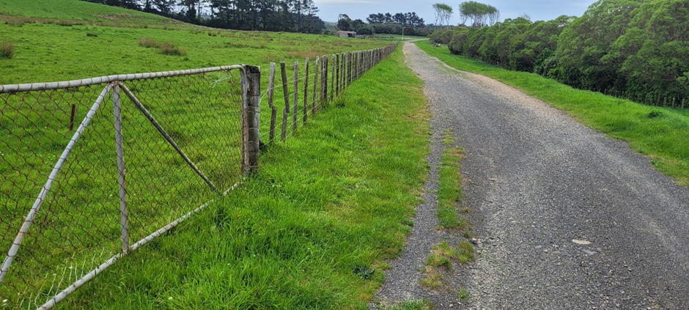

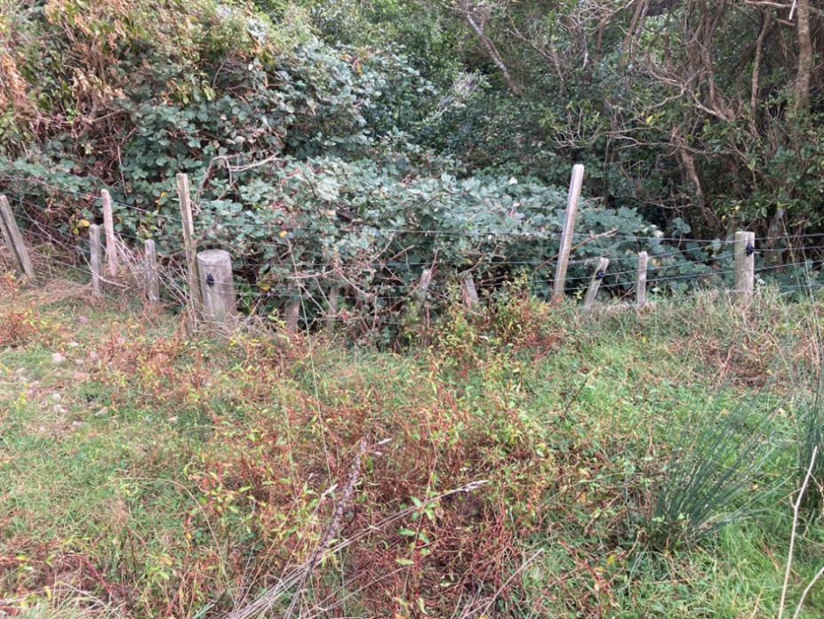
Stock yards:
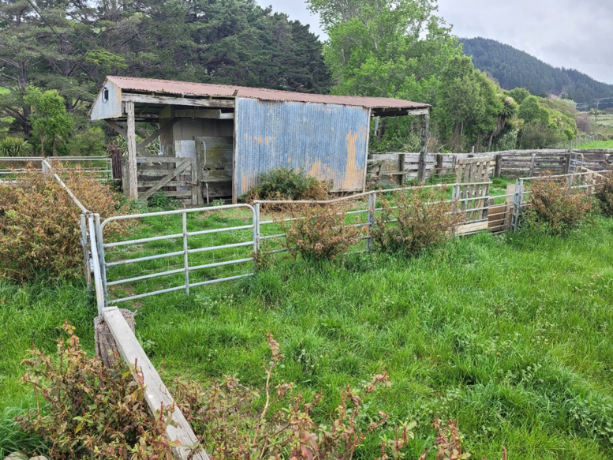
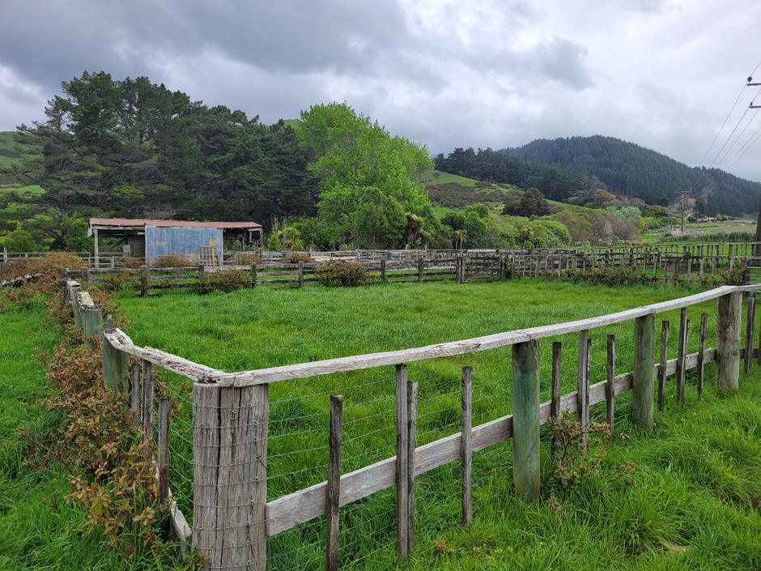

Appendix Three
Whareroa Farm – Licence Opportunity

Application Form – Request for Tenders for Grazing Licence of the Whareroa Recreation Reserve, Kapiti Coast.

process under s17zg(2)(a) of the Conservation Act 1987 to request TENDERS FOR A LICENCE opportunity of the WHAREROA FARM, KAPITI COAST.

Please complete and return this form.

I (full name)

On behalf of (company/partnership name, if applicable)

trading as (trading name, if applicable)

address

submit the following information as requested by paragraphs 5.1 – 5.2 (including all subparagraphs) of the OT document.

Signed:

Date:

Please provide the following additional information:

contact phone number

email address

website address (if applicable)

names and addresses of any other partners/ joint venture members:

names and contact details for any other contact persons for the proposal:

Wellington Conservation Management Strategy 2019 – Section 4.7: Grazing and farming

